Request for Proposal

Funding Period:
January 1 – December 31
(calendar year following award issuance)

Contact information:

The Sea Otter Foundation & Trust
P.O. Box 351946
Westminster, CO 80035

Diane Tomecek, President

www.SeaOtterFoundationTrust.org
grants@SeaOtterFoundationTrust.org

303-475-1805
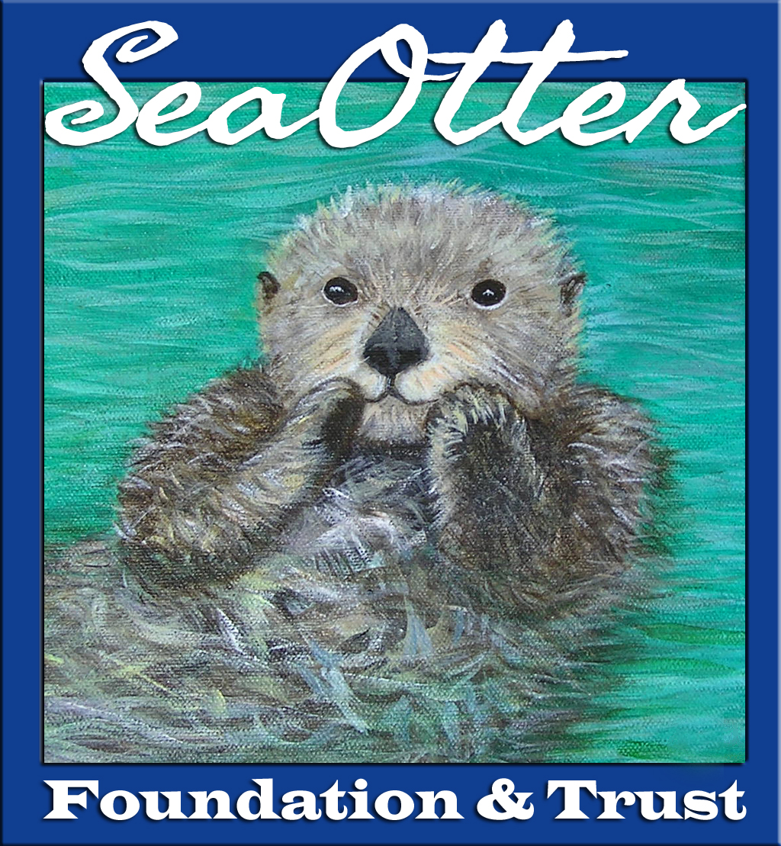
IMPORTANT NOTICE

In an effort to be environmentally conscious, applications must be submitted electronically as a PDF to the following e-mail address: grants@SeaOtterFoundationTrust.org.

Please contact us with any questions, concerns or a desire to submit electronically via dropbox.
Our mission: Ensuring the survival and recovery of sea otters (Enhydra lutris) in their habitats by building funds to support research, conservation and education.

Hello everyone!

Welcome to the Annual funding RFP for The Sea Otter Foundation & Trust (SOFT). We are excited and exceptionally honored to have you considering an application to our organization.
Important Dates:
Application Deadline:
October 1
11:59 p.m. MDT

Grantees selected
& Notified:
Begins
December 15

Checks issued:
December 31

Follow-up Reporting
Requirements

6-month
update report & video:
June 30

12-month
final report & video:
December 15

Some advisements regarding the process:

- The application is best filled out in Word as the text boxes can be resized to suit your need(s). Save as a PDF for electronic submittal. All applications must be submitted electronically to grants@seaotterfoundationtrust.org.
Please note some important dates: the deadline for applications:
October 1, 11:59 p.m. MDT; notification of awardees: Begins December 15.

- The average grant amount is a guideline for you; we encourage larger requests up to a maximum of $7,500. However, please be conscientious with your request; do not automatically apply for the maximum. Be purposeful with your budgets.

- For questions regarding direct vs. indirect costs, please refer to our Indirect Cost Policy on our website:
www.seaotterfoundationtrust.org/who-we-fund/

- SOFT’s funding is based on the calendar year, so if your program or project is multi-year, please submit your request for needs within the funding period. Applications are due each year on October 1 (refer to Part VI, D); if you have a multi-year project, you need to re-apply each year.

- We encourage partnerships and collaboration, therefore we expect applicants to utilize financial resources wisely and not duplicate efforts (refer to Part V, D).

- SOFT requires a 6-month update report and video presentation and a final 12-month final report and video presentation (refer to Part VIII, Certification & Acceptance for additional details and other specific requirements). Requirements & forms are provided with funding award.

The Sea Otter Foundation & Trust (SOFT) does not fund corporations (without an associated nonprofit 501(c)(3)), individuals (without the backing of a higher education institution), general operating costs (see also our indirect vs. direct cost policy), fundraising, marketing initiatives or website design costs.

We wish you the best of luck and look forward to reviewing your applications! Should you have any questions, please feel free to contact us.

Sincerely,
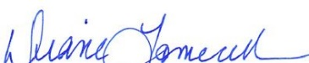

Diane Tomecek
President & CEO
Sea Otter Foundation & Trust Grant Application Form

PART I: CONTACT INFORMATION

Legal Name of Organization or Higher Education Institution seeking funding:

DBA (if applicable):

Mailing Address (and Physical Address if it is different and not confidential):

Phone: Fax:

FEIN/EIN

Website:

Email Address:

Name of CEO, University Advising Professor,

Exec Dir:

Phone: Email:

Applicant Contact Name (if different from above): Title:

Course of Study (if applicable):

Phone: Email:

PART II: ORGANIZATION INFORMATION

Nonprofit Organization/Higher Education Institution Information

Year Founded:

Mission Statement:

Vision Statement (if available):

PART III: TAX EXEMPTION/ELIGIBILLITY INFORMATION

Tax Exemption Status:
501(c)(3) – attach IRS certificate to application (nonprofit organizations)

Are you a past applicant or award recipient? Do we have your IRS certificate? If yes, then there is no need to reattach; simply check this box

Name of Fiscal Agent/Sponsor/Government Entity/University or College:

If you are not a nonprofit organization [501(c)(3)] or Higher Education Applicant, please describe your current status or purpose in requesting funding from SOFT:

PART IV: GRANT REQUEST INFORMATION

- Average grant award: $5,000; Maximum grant: $7,500

(Be conscientious with your request - do not automatically apply for the maximum)
- We will not fund general operating expenses, including wages, salaries or travel (see limits in cost policy for project related travel).
- We will not fund website(s) and their development, any fundraising and/or marketing initiatives, documentary films or administrative costs.
- For a comprehensive list of acceptable funding areas, please review & download our Indirect Cost Policy: www.seaotterfoundationtrust.org/who-we-fund/. Be proactive with your time as we are not responsible for automatically rejected applications requesting non-fundable items or areas.

$

Type of Grant Requested (select one): Amount of Request:

Medical (Veterinary) Supplies or Other Equipment

Please specify:

Program or Project Support

Name of Program or Project:

Other

The Sea Otter Foundation & Trust has three funding priority areas – Research, Conservation & Education. Which of these applies to this project or program? YOU MUST specify only ONE. Please consider your project scope purposefully in this regard. Your application will be rejected if you do not specify a primary purpose. Briefly describe:
Do you have questions about limiting your project scope area? Please contact grants@seaotterfoundationtrust.org by
September 25.

Research

Conservation

Education

PART V: PROJECT/PROGRAM NARRATIVE

- Describe in detail your program/study/project as it relates to sea otter research, conservation & education. If this is a multi-year project, please attach an overall project summary in addition to the narrative for this specific funding grant:

(Please expand text box or attach additional pages as necessary)

- Describe your work (past & present) as it relates to sea otters:

C. What specific Sea Otter Population is served through this project or program:

D. Are there other programs or organizations that have similar goals? Describe how you currently partner with them or will partner with them in the future:

E. What other sources of funding have been obtained or are being sought for this project or program:

F. Why should your project be funded in lieu of other projects? What makes your project unique?

PART VI: FINANCIAL INFORMATION

Nonprofit organization – complete Parts A - E

Higher Education Institution applicant – complete Parts B - E

A. Nonprofit Organization
___/___/_____

Current Budget for Fiscal Year Ending:

Income: Expenses:

__/__/__
__/__/___
B. Program/Project Budget: Dates: from: to:

Income (anticipated or actual): Expenses (anticipated or actual):

Anticipated Actual Anticipated Actual

C. Amount of Grant Request (from PART IV above):
$

The Sea Otter Foundation & Trust distributes on an annual basis.

The funding period is the calendar year: January 1 – December 31.

D. Is this a multi-year project? Do you anticipate additional funding requests?

E. Please attach a detailed budget for your project (required).
Attacheded

PART VII: CHECK PROCESSING INFORMATION

Legal Name of Institution for Grant Award Check:

Mailing Address of Institution for Grant Award Check:

PART VIII: CERTIFICATION & ACCEPTANCE

By signing below, I certify that the information contained in this application is true and correct to the best of my knowledge.

I accept that if awarded funding, a 6-month written project update and a video presentation will be provided by June 30. Additionally, a final 12-month written report and video presentation will be provided by December 15. These materials for this funding period will be provided to The Sea Otter Foundation & Trust (SOFT) for use in SOFT’s impact statements and/or SOFT’s marketing materials. In addition to the written update, video(s) and final report(s), I agree to work in partnership with The Sea Otter Foundation & Trust for filmed interviews, video presentation(s) and other promotional marketing & media related to my funding grant in order to provide updates and educational promotion to the general public about the awarded grant. For nonprofit organizations, media contract requires Sea Otter Foundation & Trust be acknowledged as a partner on nonprofit entity’s website with appropriate backlinks to Sea Otter Foundation & Trust’s website. All successful applicants will be required to sign and abide by our Media Contract. This contract includes more specifics regarding required video presentations and will follow with award check. If you wish to review the media contract prior to submitting application, please contact grants@seaotterfoundationtrust.org by September 25).

Written report forms for the 6 and 12 month reports are provided on our website: https://seaotterfoundationtrust.org/who-we-fund/.

In addition to the above, I accept that if my/the work proposed herein, changes in any way, I or named organization, must inform the Sea Otter Foundation & Trust regarding the change or changes as soon as possible and understand that the Sea Otter Foundation & Trust reserves the right to revoke the funding grant (for a full refund to Sea Otter Foundation & Trust) if the scope of work changes inexorably from the work scope stated within this application or accompanying reports and videos. Sea Otter Foundation & Trust also reserves the right to revoke the funding grant (for a full refund to Sea Otter Foundation & Trust) if any/all of the reporting requirements fail to be submitted or provided.

CEO/Executive Director/Advising Professor Date

Higher Education or Other Project Applicant Date

The Sea Otter Foundation & Trust (SOFT) looks forward to working with you and/or your organization to ensure the survival and recovery of sea otters in their habitats.

