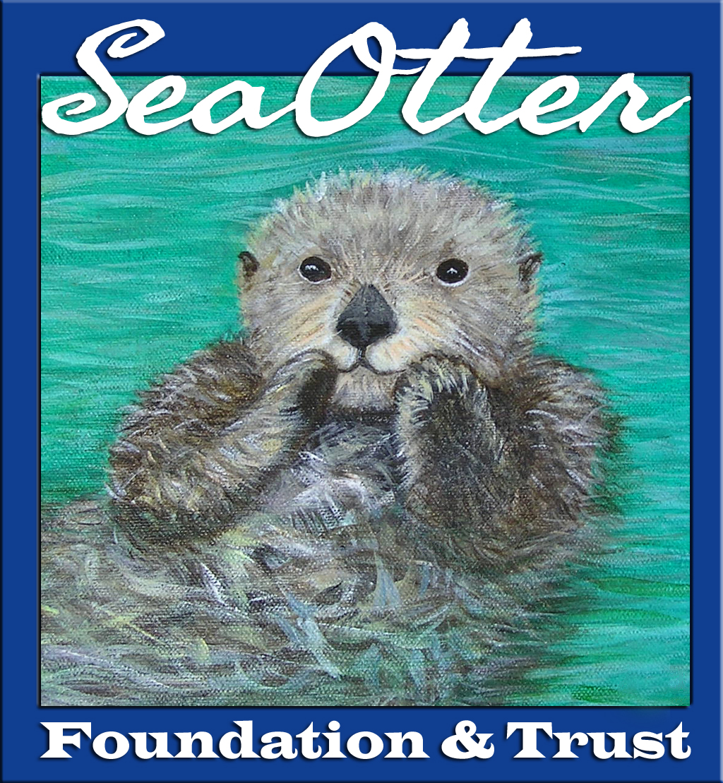

Sea Otter Foundation & Trust (SOFT)
6-Month Grantee Report
1. Name/Organization Name:

2. Name of Project:

3. To date, have the grant funds been utilized?
Yes/No/Partially

If so, describe how.

If not, give an estimate of when the funds will be utilized understanding that funds are required to be used by the end of granting period.
(Please note: SOFT reserves the right to request receipts or expenditure detail statements)

4. Update narrative: describe in detail what the project has achieved for the 1st 6 months of funding. Provide information on how SOFT grant funds have helped achieve your project or your organization’s project goals.

(Guideline: two to three paragraphs. Include information on any training sessions or public education your project has conducted.

For research based projects, give insights to how your project is impacting or has impacted the conservation of sea otters.)

5. Please attach photographs, images or charts which illustrate the achievement of project goals.
(Provide image, illustration or chart credit if different from project name).

6. What do you anticipate for your project during the 2nd 6 months of funding?

Special note: By submitting this report, you give Sea Otter Foundation & Trust (SOFT) the right to use information, images or illustrations provided in SOFT marketing & fundraising efforts, helping us help you. Please provide any necessary copyright or credit information for submitted images, illustrations or text. Applicant initials:

