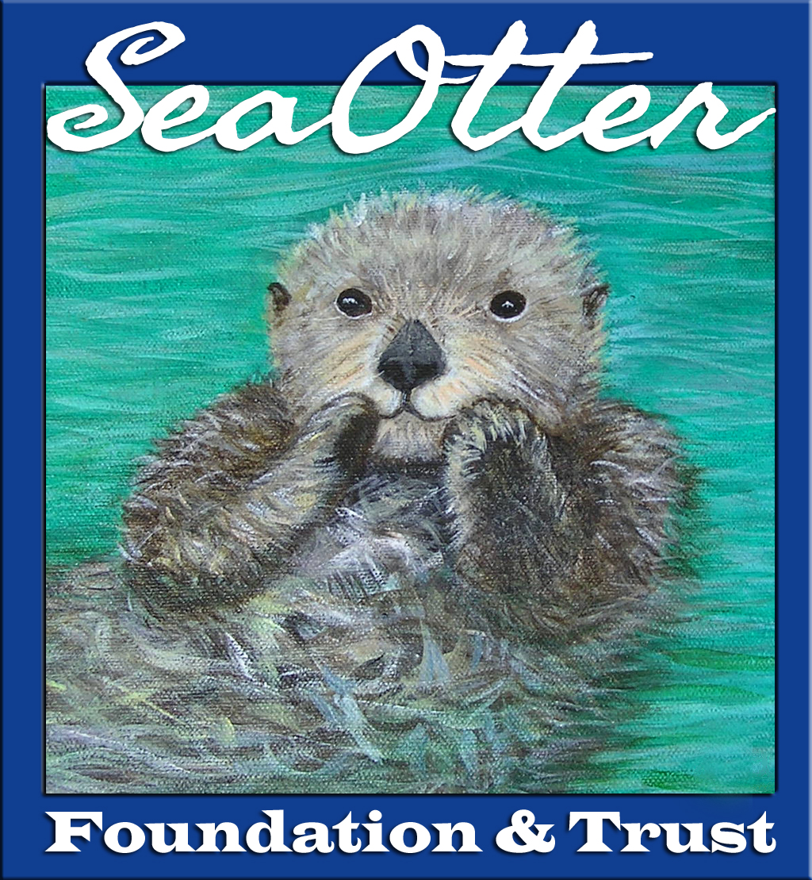

Sea Otter Foundation & Trust (SOFT)
12-Month/Final Grantee Report

1. Name/Organization Name:

2. Name of Project:

3. Have all the grant funds been utilized? If not, have you contacted SOFT to explain why?
Yes/No/Partially

4. Update narrative: describe in detail what the project has achieved.

(Guideline: two to three paragraphs. Include information on any training sessions or any public education your project has conducted.

For research based projects, give insights to how your project is impacting or has impacted the conservation of sea otters.)

5. Please attach photographs, images or charts which illustrate the achievement of project goals.
Include images of your project achieving the work SOFT funded.
(Provide image, illustration or chart credit if different from project name).

6. Was there a research paper published? Any news articles published? Please share news articles or paper publication date/intended date.

7. What is the future of the project?

Students: Have you completed your graduate studies? Describe any dissertation process you have completed.

8. Describe in detail how SOFT impacted your project. Describe the significance of having received SOFT funding.

Special note: By submitting this report, you give Sea Otter Foundation & Trust (SOFT) the right to use information, images or illustrations provided in SOFT marketing & fundraising efforts, helping us help you. Please provide any necessary copyright or credit information for submitted images, illustrations or text. Applicant initials:

